
ОБЩЕСТВО С ОГРАНИЧЕННОЙ ОТВЕТСТВЕННОСТЬЮ
«ЛАЗЕРТАГ»

ПАСПОРТ

Смоленск
LIMITED LIABILITY COMPANY
LASERWAR

PANDORA BOX

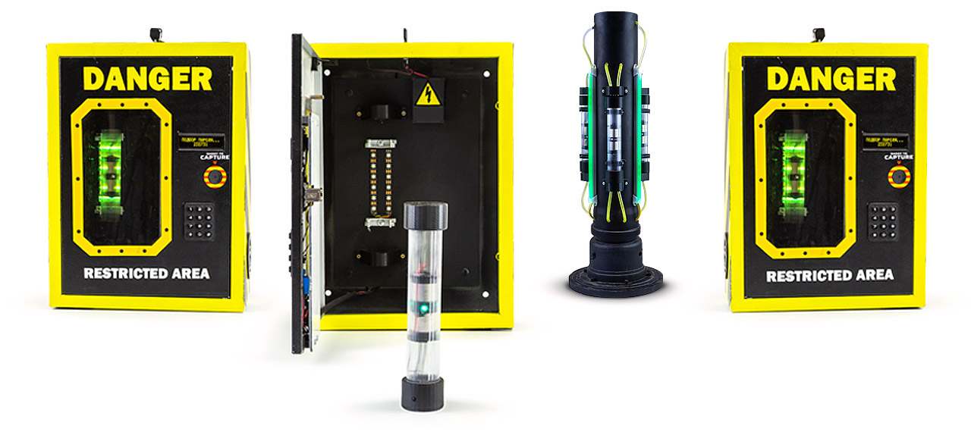

SPECIFICATION

Dear Customer!
Our company welcomes and thanks you for the decision to buy our products, and is confident that the purchased device will bring you a long-term pleasure. The warranty certificate establishes the guarantee of the product in the amount provided for by the Law on consumer protection of the Russian Federation.
This warranty certificate is valid for 12 months from the purchase date of the product, and is subject to the guarantee terms.
Warranty Terms:
1. The guarantee is effective upon presentation of this coupon, which shall contain the serial number of the product and the date of its purchase, confirmed by the service centre.
2. These guarantee obligations apply to products acquired only from the official LASERTAG representative or the official dealer.
3. The present guarantee is invalid if the product deficiencies have occurred in the following cases:
- failure to comply with Operating instructions;
- mechanical damage;
- penetration of extraneous items, liquids, etc.;
- animal activities;
- unauthorized access to the parts of the game set by non-authorized persons;
- use of the product for purposes for which it hasn't been made;
- Acts of elements (natural disaster, fire, accidents, etc.);
- the game set malfunction in case of faulty power network and/or poor care of the product.
4. If the warranty certificate is lost, no duplicate is issued.

8. Guarantee obligations
The manufacturer guarantees the reliability of the operation of an individual LASERWAR set if the consumer has complied with the conditions of use. Technical support is provided within 12 months of the sale date. The manufacturer undertakes to replace or repair an individual set of equipment free of charge, if the customer has complied with the rules for the device transportation, storage, operation and delivery of defective equipment to Smolensk City.

9. Contact information

Official website:
www.laserwar.com

E-mail: Purchase Date: _________________________
info@laserwar.com
help@laserwar.com

Skype:
info@laserwar.com
help@laserwar.com

______________________________________
signature

2
7
Information on the repairs performed during the maintenance period (completed by the Service centre performing the warranty repair works)

Date:__________________  Completed work: _____________________________________________________________________  Service centre stamp | Date:__________________  Completed work: _____________________________________________________________________  Service centre stamp
Date:__________________  Completed work: _____________________________________________________________________  Service centre stamp | Date:__________________  Completed work: _____________________________________________________________________  Service centre stamp
Date:__________________  Completed work: _____________________________________________________________________  Service centre stamp | Date:__________________  Completed work: _____________________________________________________________________  Service centre stamp

1. Description
The Pandora Box is a set of three devices and an activator to complete the scenario.

2. Scope of application
The device is designed for scenario events, tactical training, corporate and entertainment events.
3. Contents of delivery
1. Pandora box - 3 pc.
2. Activator - 1 pc.
3. Specification - 1 pc.

4. Basic technical Data
Dimensions, cm | 3 х (42х30х12 cm)  + 1 х (25х25х70 cm)
Charger, B | Tube - micro-USB, 5V  Activator, Box - Li+, 7.4V
Mass, kg | 10

5. The device
The Pandora box is made in a brightly colored metal case. Inside the body there is a battery, control junctions, mounting hardware. The body has control button, a photosensor, a power socket and an OLED display. Inside the body there is a "radioactive" tube in special holders.
The Activator is a construction with sockets for the installation of three radioactive tubes as well as a sound and light indication.

3
6
6. Maintenance
All parts of the set must be treated with care if you want the equipment to function properly. Avoid contamination and damage to the IR diode and the photosensor. There shouldn't be any moisture inside the body. Charge the battery on time. Don't hit the device.
7. User's manual
The device is switched on with the key. The emergency switch on button is intended for opening the storage by the service company.
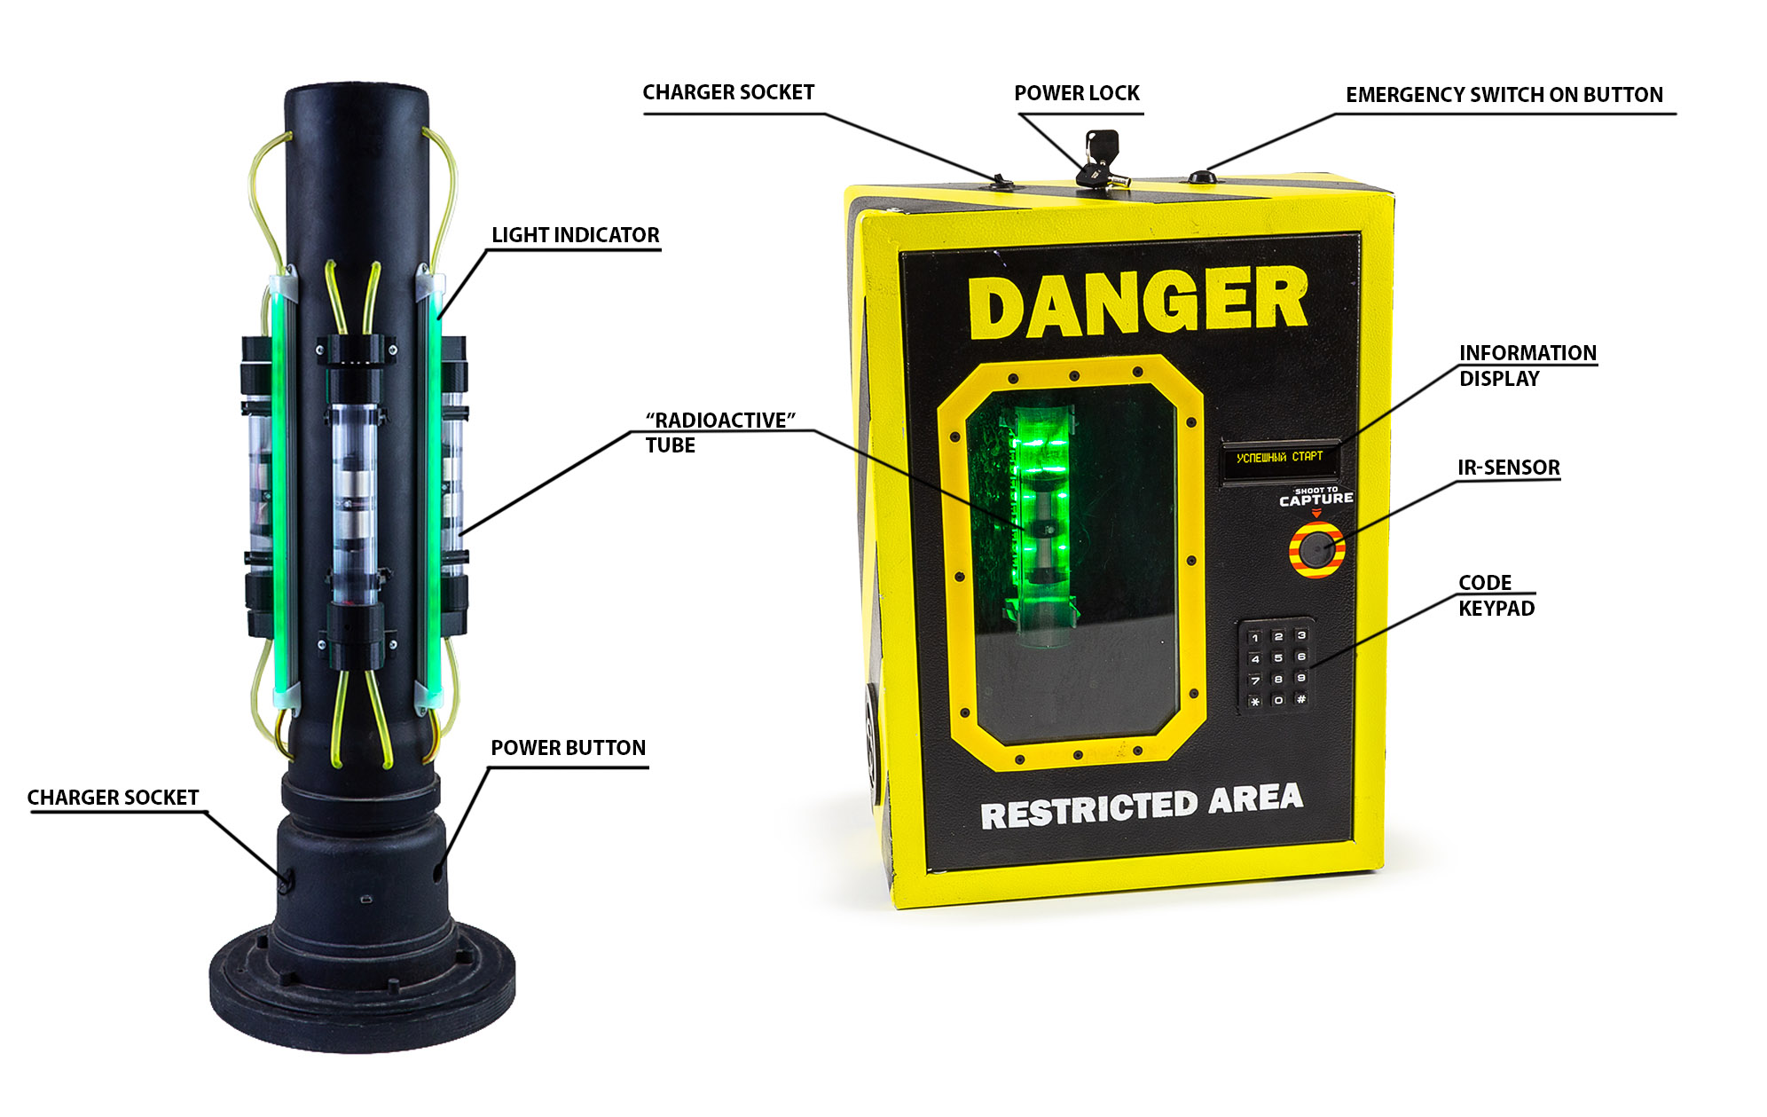
After switching on the device is ready to use: it is waiting for a shot in the sensor from one of the playing teams. The shot starts decoding of the first digit of the code. After 2 minutes the number is displayed and a shot is expected to continue the decoding process. After decoding all the digits, you can enter the code on the keyboard and the box will open. A shot at the sensor by an enemy team resets the code and starts a new decryption process.
After opening the box, it is necessary to remove the "radioactive" tube and install it in the "activator". The tube taken out of the box emits "radiation" impulses and reduces the player's hp.
After all three tubes have been installed in the activator, the procedure of their processing is automatically started with a light and sound indication. Upon the "activation" completion, the scenario is considered completed.

Equipment Maintenance Rules
1. Weather conditions. At the course of manufacture we make different tests to see how well the equipment works under different weather conditions. Despite this, we strongly recommend that the equipment shouldn't be used in the rain and at temperatures below -20 °C.
What should I know when using the equipment in poor weather conditions?
The most important thing is to avoid getting moisture inside the device. If this happened, turn off the device, dry the equipment at room temperature for at least two hours.

2. Power source. Lithium batteries are used as a source of power in the Pandora Box game set.
The box and activator are charged by any Li+ charger from LASERWAR.
The "radioactive" tube must be charged with a micro-USB charger.

3. Storage conditions. It is necessary to store the equipment in a well-ventilated room at temperature from + 18 °C to + 30 °C and relative humidity of 45-65%.
The warranty is 14 days for speakers, and IR modules. These components are expendable materials.

WARNING! In the case of improper operation of the accumulator (charging by an unrelated type of a charger), the warranty doesn't cover the battery!

4
5

